Associate Professor Turgut Yilmaz
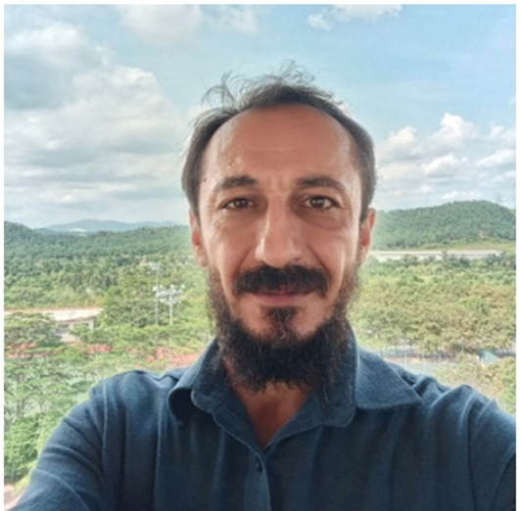
- Email: turgut.yilmaz@xmu.edu.my
- Office: A1-380
- Research interests:
  - Electronic Structure of Quantum Materials
  - Synchrotron-Based Spectroscopy (ARPES)
  - Intercalation and Interface Engineering
  - Correlated-Electron Phenomena
  - Spintronics and Quantum Magnetism
  - Topological Superconductivity and 2D Electron Gases (2DEGs)
BIOGRAPHY
Dr. Turgut Yilmaz is an Associate Professor of Physics at Xiamen University Malaysia, specializing in experimental condensed matter physics. His research focuses on understanding and engineering the electronic structure of quantum and topological materials using angle-resolved photoemission spectroscopy (ARPES) and synchrotron radiation techniques. Before joining Xiamen University Malaysia, Dr. Yilmaz conducted postdoctoral research at the National Synchrotron Light Source II (Brookhaven National Laboratory, USA) and the University of Connecticut, where he contributed to several landmark studies on topological insulators, van der Waals materials, and correlated electron systems. He continues to collaborate internationally, integrating spectroscopy, materials synthesis, and quantum engineering to uncover novel phenomena relevant to spintronics and energy-efficient quantum devices.

RESEARCH INTERESTS
- Electronic Structure of Quantum Materials
Mapping and engineering the band structures of topological insulators, transition-metal dichalcogenides (TMDs), and kagome/pyrochlore systems using advanced photoemission spectroscopy.

- Synchrotron-Based Spectroscopy (ARPES)
Development and use of ARPES to explore electronic, magnetic, and structural correlations in condensed matter systems.

- Intercalation and Interface Engineering
Designing van der Waals heterostructures and intercalated materials to tailor charge transfer, magnetism, and emergent quantum phenomena.

- Correlated-Electron Phenomena
Investigating flat bands, charge order, and non-Fermi liquid behavior to understand and control many-body interactions.

- Spintronics and Quantum Magnetism
Exploring spin-dependent transport and magnetic order in low-dimensional and topological materials for spintronic device applications.

- Topological Superconductivity and 2D Electron Gases (2DEGs)
Studying interface-induced superconductivity and orbital-selective effects in oxide/metal and topological heterostructures.

EDUCATIONAL BACKGROUND
- Ph.D. in Physics – University of Connecticut, USA (2013–2016)
- M.S. in Physics – University of Connecticut, USA (2009–2013)
- B.S. in Physics – Ondokuz Mayıs University, Türkiye (2003–2007)

WORKING EXPERIENCE
- Associate Professor, Xiamen University Malaysia (Sep 2025 – Present)
- Gratis Appointment, University of Connecticut, USA (Mar 2023 – Present)
- Research Scientist, Xiamen University Malaysia (Oct 2024 – Sep 2025)
- Postdoctoral Researcher, Brookhaven National Laboratory, USA (Feb 2019 – Dec 2022)
- Postdoctoral Researcher, University of Connecticut, USA (Feb 2018 – Feb 2019)

EXPERTISE
- ARPES system design and operation
- Synchrotron radiation techniques (photoemission, X-ray absorption)
- Epitaxial growth (MBE) of topological and quantum materials
- Ultra-high vacuum (UHV) instrumentation
- Structural and magnetic characterization (XRD, SQUID)
- Electronic structure modeling and spectral analysis
REPRESENTATIVE PUBLICATIONS
- T. Yilmaz, Y. S. Ng, A. Rajapitamahuni, A. Kundu, H.-Q. Wang, J.-C. Zheng, E. Vescovo, “Intercalation induced quasi-freestanding layer in TiSe₂,” Phys. Rev. B 112, 085114 (2025).

- T. Yilmaz, X. Tong, J. T. Sadowski, K. E. Lutterodt, K. Kisslinger, E. Vescovo, “Evolution of the Fermi Surface of 1T-VSe₂ across a Structural Phase Transition,” Materials 17 (18), 4498 (2024).

- A. Rajapitamahuni, T. Yilmaz, K. Kaznatcheev, A. Kundu, E. Vescovo, et al., “The Electron Spectro-Microscopy Beamline at NSLS-II,” Synchrotron Radiation News (2024).

- H. Wu, L. Chen, P. Malinowski, Q. Deng, T. Yilmaz, et al., “Reversible Non-Volatile Electronic Switching in a Van der Waals Ferromagnet,” Nature Communications 15, 2739 (2024).
- J. Huang, L. Chen, C. Setty, T. Yilmaz, E. Vescovo, et al., “Non-Fermi Liquid Behavior in a Correlated Flat-Band Pyrochlore Lattice,” Nature Physics 20, 603 (2024).

- T. Yilmaz, X. Jiang, D. Lu, P. M. Sheverdyaeva, A. V. Matetskiy, et al., “Dirac Nodal Arc in 1T-VSe₂,” Communications Materials 4, 47 (2023).

- T. Yilmaz, E. Vescovo, “Gapless Surface Electronic Structure of 1T-TiSe₂ in the Distorted Phase,” Phys. Rev. B 108, 155105 (2023).

- T. Yilmaz, E. Vescovo, J. T. Sadowski, B. Sinkovic, “Spectroscopic Evidence of Highly Correlated Electrons in VSe₂,” Phys. Rev. B 105, 245114 (2022).
HONORS/AWARDS

